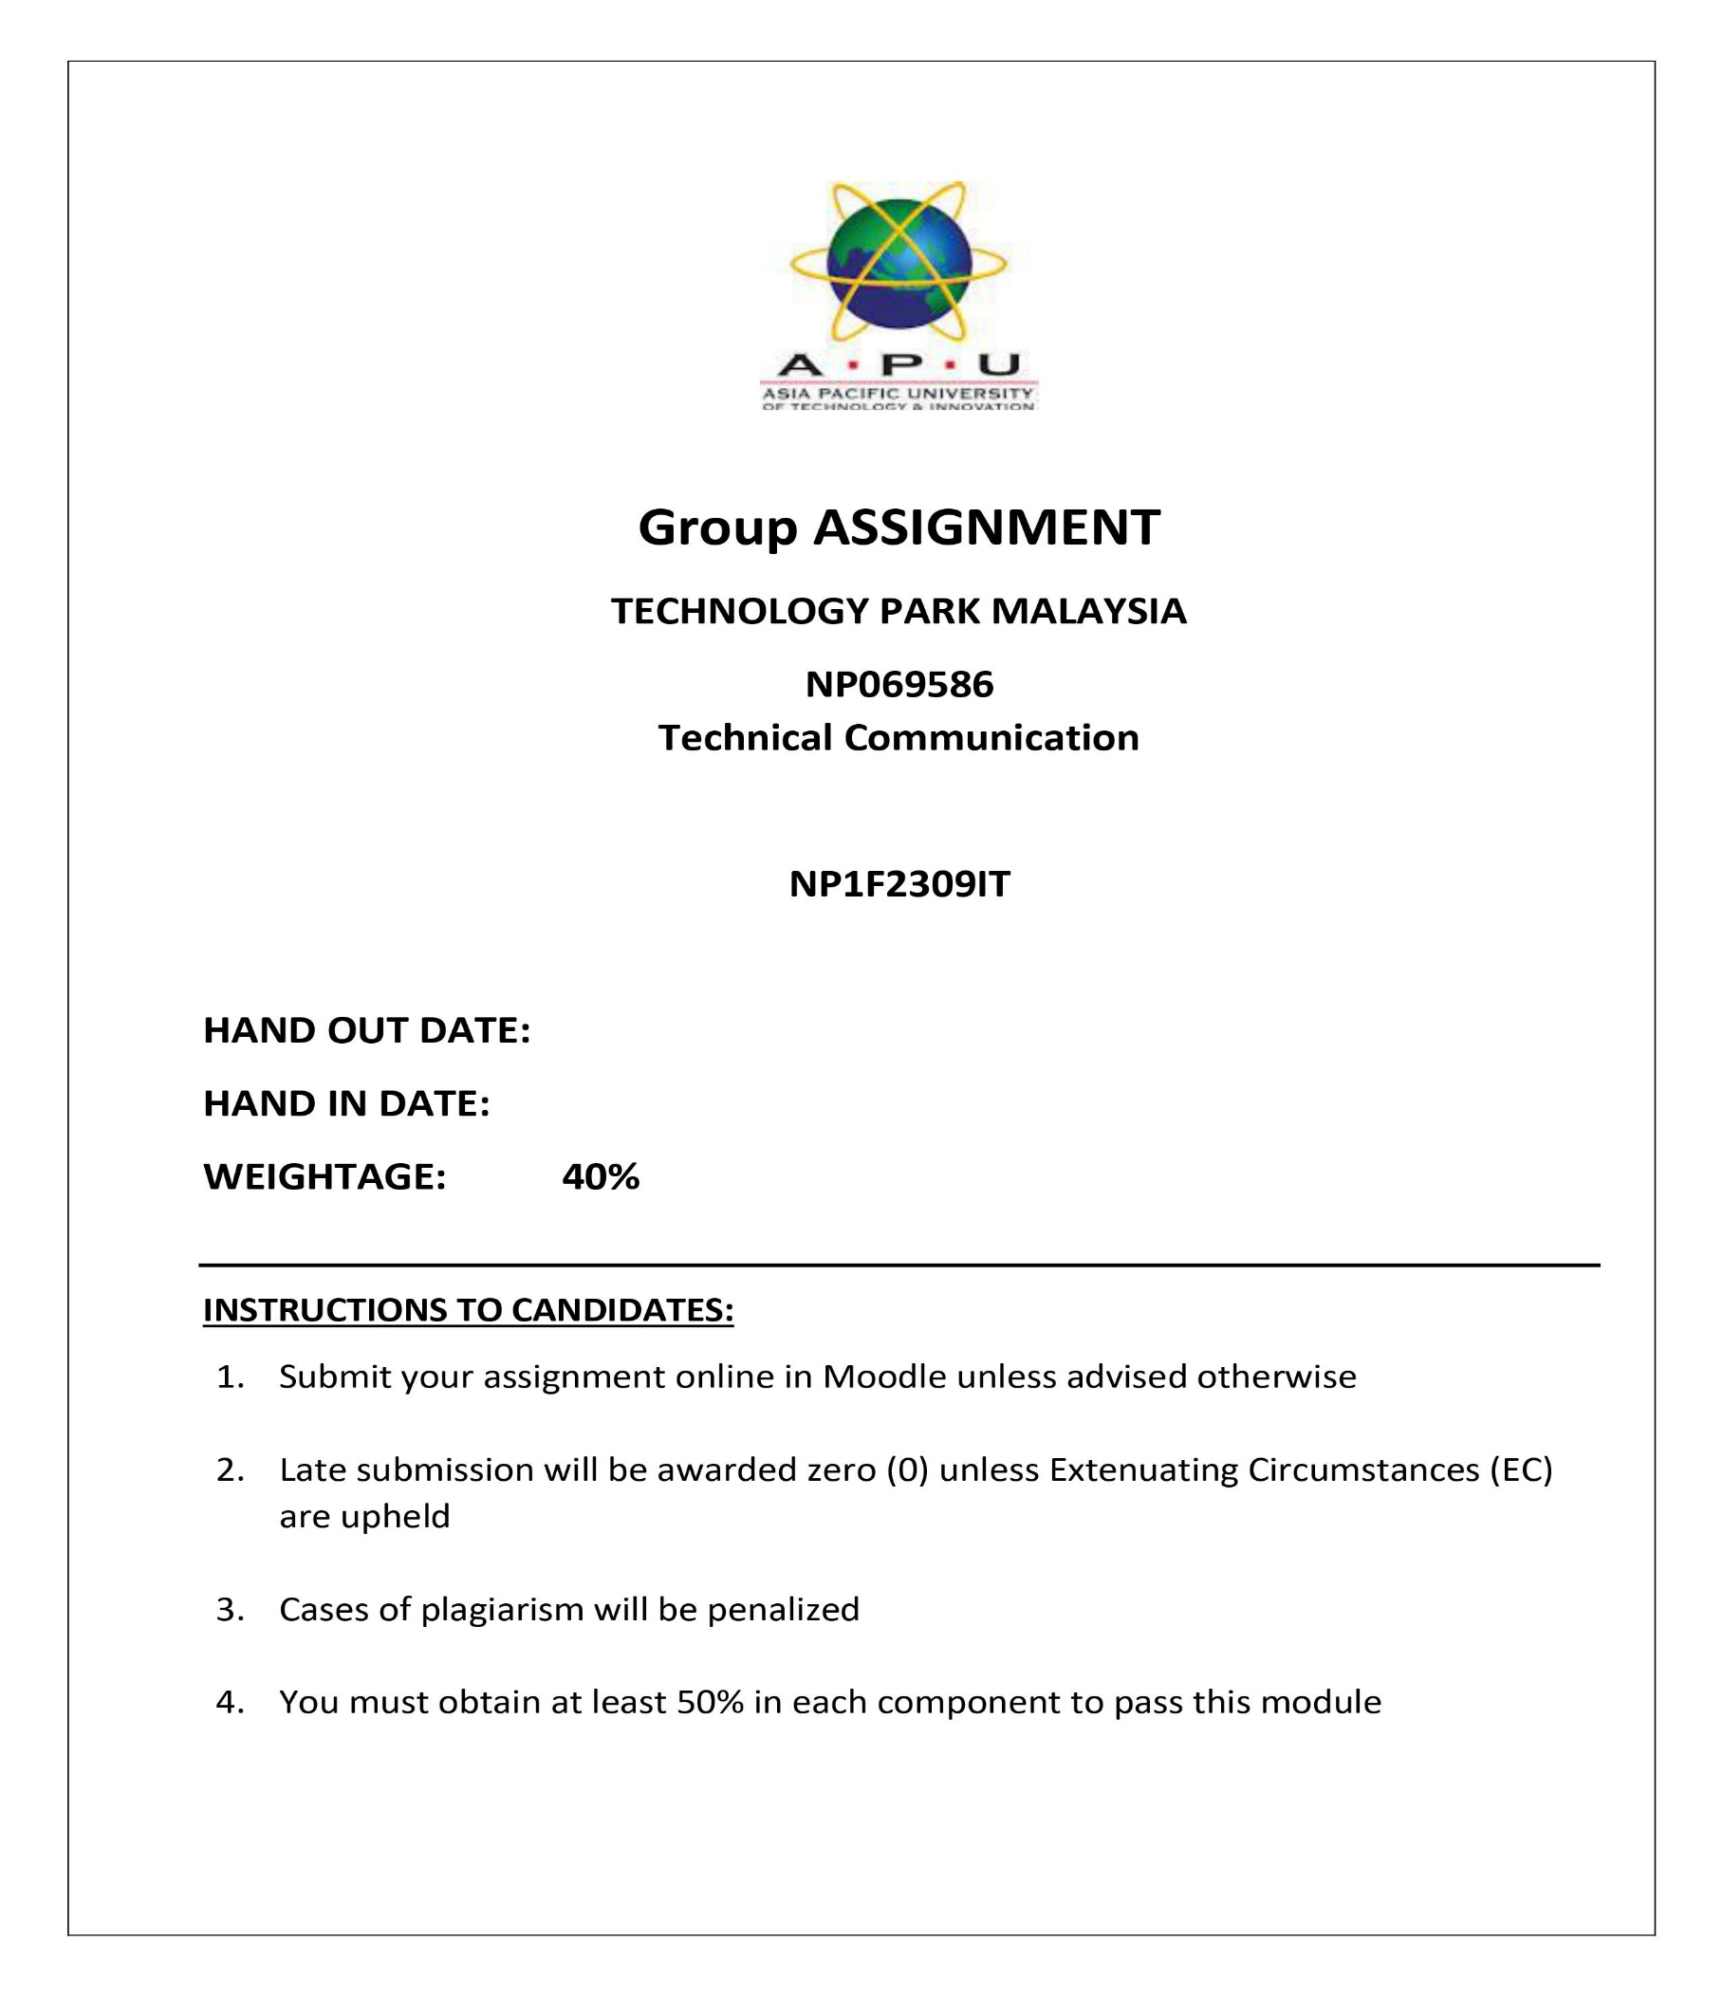

# Introduction

MICROSOFT IT Pvt. Ltd. is a Nepal-based company that has been building software and transforming technology for the past 11 years, assisting businesses in establishing a digital presence. The following are the best companies for which we provide technical support:

1. Krishi Bikash bank
2. Nico Insurance
3. Kathmandu codes
4. LBEF college
5. Nepal Bank LTD.

Now, we want to support Elevate Official, a top food production firm situated in Nepal.   
We would like to submit our technical support purpose to the Elevate official.

The increase in product at The Elevate Official means that IT support requirements may be fulfilled more efficiently and cost-effectively. Sandra Davison-Wilson, The Elevate's Vice President of Administration and Finance, asked IT Services management to examine their areas' support requirements and current service delivery plans. The purpose of this document is to recommend that higher-level officials develop an IT support model that standardizes the support structure, improves support request management, and defines norms and protocols for everyone to follow. The new models will also cover resources, roles, responsibilities, expectations, services, and staff reporting, among other company-related themes.

Elevate officials acknowledge that boosted technical assistance is essential to support production expansion while also providing acceptable customer support services. The challenges of the new model are:

1. Identifying funding sources for IT;
2. Aligning human resources with elevate official requirements;
3. Managing physical infrastructure growth in Grand Rapids;
4. Addressing the uniqueness of technology that supports elevate official growth;
5. Implementing a mixed support strategy;
6. Maintaining legacy systems and human resources to support customers.

The two proposed assistance models are a blend of delivery mechanisms designed to meet the Elevate official's criteria.

The CPTS and COP models will combine resources to create a support structure similar to the current IT Services model. The model will build on existing processes and procedures while also incorporating roles, responsibilities, and staff reporting.

The KCAD model will continue to provide independent services for primary service desk support of incident, request, and problem management on desktops. The legacy support services will be integrated with the Big Rapids support system utilizing the MICROSOFT IT Pvt. Ltd standard service management software. This would codify incident, request, and problem tracking, as well as standardize workflow processes, resulting in faster response times for help beyond service desk professionals.

Finally, the growth of The Elevate Official requires extra network infrastructure support resources. The complexity and diversity of university applications supplied via the internet have grown over time. Unfortunately, application delivery performance has been poor, resulting in customer displeasure, reduced productivity, and the potential loss of future students. This third leg of the support model is a shared resource that will be part of the existing network infrastructure team, based in Grand Rapids, with a major focus on Grand Rapids and satellite campus sites.

**Qualifications**

MICROSOFT IT Pvt. Ltd. provides a wealth of expertise, talents, and credentials, allowing us to successfully carry out Elevate Official's proposed IT support project. Our organization and key personnel have the academic and professional credentials necessary to establish credibility and provide outstanding outcomes. We bring the following qualifications to the project.

1. **Firm Experience:** Over 11 years of expertise with software development, technology transformation, and IT support services. Proven track record of effectively implementing IT projects across multiple industries, including banking, insurance, and education.
2. **Key Personnel Expertise:** Our staff includes qualified IT specialists that have extensive knowledge and hands-on expertise in IT support, infrastructure management, and application performance optimization. Academic credentials include degrees and certificates in computer science, information technology, project management, and other subjects.
3. **Past Project Experience:** Similar IT support initiatives have been successfully completed for enterprises of varied sizes and complexity. Standardized support structures, improved request management systems, and streamlined IT infrastructure improved performance and reliability.
4. **Credibility and trust:** Our company's reputation for providing high-quality services while fulfilling project deadlines on time and under budget.   
   Client testimonials and references attest to our professionalism, knowledge, and commitment to excellence.
5. **Continuous Learning and Development:** Commitment to continuous training, certifications, and staying current on industry developments and best practices.   
   Participation in professional forums, workshops, and conferences to constantly improve skills and knowledge.

Our qualifications demonstrate our readiness and expertise to take on the IT support project for Elevate Official, assuring a successful and effective collaboration that fosters corporate growth and success.

**Objectives of this project**

1. **Standardize Support Structure:** Create a standardized IT support approach that is consistent with Elevate Official's growth and operational requirements.
2. **Improve Support Request Management:** Make support request management methods more efficient and effective to ensure that IT issues are resolved on time.
3. **Define Norms and Protocols:** Create clear norms, protocols, and rules for all stakeholders to adhere to in terms of IT support, roles, duties, and reporting.
4. **Allocate Funding Sources:** Locate and obtain appropriate funding sources for IT initiatives and infrastructure improvements needed to support Elevate Official's growth.
5. **Align Human Resources:** Ensure that human resources are in line with Elevate Official's needs, including staffing levels, skills, and expertise.
6. **Manage Infrastructure Growth:** To support expanding operations, strategically manage physical infrastructure growth in Grand Rapids and satellite campuses.
7. **Address Technology Uniqueness:** Create solutions to address the specific technology requirements that enable Elevate Official's growth trajectory.
8. **Implement a Mixed Support Strategy:** Combine different support models (CPTS, COP, and KCAD) to deliver complete and specialized support services based on specific requirements.
9. **Maintain Legacy Systems:** Ensure the continuity and support of legacy systems, as well as the human resources required to efficiently satisfy customer service expectations.
10. **Improve Application Delivery Performance:** Improve the performance of university applications supplied via the internet to increase customer happiness, productivity, and retention.

**Problem statement**

1. Elevate Official's increasing operations lacks a defined IT support framework.
2. Support request administration is inefficient, and standards and protocols are unclear.
3. Challenges in identifying and obtaining funding for IT initiatives.
4. It is difficult to align human resources with Elevate Official's requirements.
5. Inadequate management of physical infrastructure expansion.
6. Issues in addressing the uniqueness of the technology supporting Elevate Official's growth.
7. The need to establish a diversified support plan.
8. Challenges in maintaining old systems and meeting consumer demands.
9. Poor performance of university applications distributed over the internet, resulting in customer unhappiness and lower productivity.

**Plans**

Information Technology Support Organizations everywhere are always challenged to Accomplish more with less and help their businesses prosper. Furthermore, our employees and customers expect us to define and improve roles and responsibilities, policies, processes, and procedures to provide structure and guidance in their work. We also need to communicate with our clients about what we can and cannot do, as well as what they may do to help.

IT Service Management (ITSM) is a process-based strategy that aims to match the delivery of information technology (IT) services with organizational goals while focusing on customer benefits. IT Service Management (ITSM) is a process-based strategy that aims to match the delivery of information technology (IT) services with organizational goals while focusing on customer benefits.   
Benefits of Following These Best

1. **Standardize the Support Structure:** Conduct a complete review of Elevate Official's current IT support framework. Create standardized procedures, protocols, and guidelines for IT support tasks. Create a centralized system to manage support requests and track resolutions.
2. **Improve support request management:** Create a ticketing system to log, prioritize, and track support requests. Establish defined escalation pathways and response time targets for various sorts of requests. Train IT support professionals on how to handle and resolve requests efficiently.
3. **Define norms and protocols:** Create a thorough IT support policy document that defines roles, responsibilities, and communication methods.   
   Conduct training sessions and workshops to ensure that all stakeholders understand and follow the specified rules and regulations.
4. **Allocate funding sources:** Collaborate with Elevate Official's financial and management departments to determine budget allocations for IT projects.   
   Investigate prospective collaborations or funding opportunities with technology suppliers or government agencies.
5. **Align human resources:** Conduct a skills gap study to determine training and recruitment requirements. Create career paths and skill development programs for IT professionals to meet Elevate Official's changing demands.
6. **Manage infrastructure growth:** Conduct a capacity planning effort to prepare for and handle infrastructure growth. Implement scalable solutions and technologies to accommodate growth without sacrificing performance.
7. **Address Technology Uniqueness:** Collaborate with Elevate Official's technology stakeholders to understand their specific requirements.   
   Customize or create IT solutions that address Elevate Official's specific technology difficulties.
8. **Implement a mixed support strategy:** Integrate the CPTS, COP, and KCAD support models to form a comprehensive framework. Assign roles and duties within each support model, and create effective communication routes.
9. **Maintain legacy systems:** Implement regular maintenance schedules and upgrades for legacy systems. Train IT personnel in legacy system support and troubleshooting strategies to ensure continuous functionality.
10. **Improve application delivery performance**: Conduct performance audits on university applications to discover bottlenecks and opportunities for improvement.   
    Implement optimization solutions, such as content delivery networks (CDNs) or caching systems, to improve application speed and dependability.

Elevate Official will be able to efficiently handle its IT support difficulties, streamline operations, improve customer satisfaction, and accomplish its growth goals through the implementation of this thorough plan.

**Budget Estimation:**

To efficiently implement the intended, Elevate Official IT support project, a financial estimate must be developed. The budget is divided into sub-dependencies, which list required resources and provide anticipated amounts for each component.

1. **Infrastructure & Hardware** 
   1. Purchase of servers, networking equipment, and hardware components: $30,000
   2. Installation and configuration of infrastructure: $10,000
   3. License fees for software and tools $15,000
2. **Software Development and Customization**
   1. Development and customization of IT support software: $50,000
   2. Integration with existing systems and applications: $20,000
   3. Testing and quality assurance: $15,000
3. **Human Resources**
   1. Project management and coordination: $25,000
   2. IT support staff salaries and benefits: $80,000
   3. Training and professional development: $10,000
4. **Consultancy and Outsourcing**
   1. External consultancy fees for specialized expertise: $15,000
   2. Outsourcing of specific tasks or services: $20,000
5. **Miscellaneous Expenses**
   1. Travel and accommodation for on-site visits: $5,000
   2. Contingency fund for unforeseen expenses: $10,000

**Total Budget Estimate: $325,000**

***Note:*** *The above budget estimate is based on a thorough examination of the project's requirements, which include infrastructure demands, software development, human resources, consulting, and miscellaneous charges. It displays a realistic budget that addresses all critical components of Elevate Official's IT support project while leaving room for contingencies and revisions throughout the implementation phase.*

This revised budget estimate gives a more precise breakdown of project execution expenses and confirms that the allotted budget is consistent with the project's scope, objectives, and deliverables. Adjustments can still be made as necessary depending on more discussions and preparation with stakeholders.

Conclusion:

Finally, MICROSOFT IT Pvt. Ltd. is well-equipped and ready to take on the Elevate Official IT support project, owing to our considerable experience, competence, and track record in software development and technology transformation. Our proposed IT support model addresses the following challenges: standardizing support structures, improving request management, defining norms and protocols, allocating funding sources, aligning human resources, managing infrastructure growth, addressing technology uniqueness, implementing a mixed support strategy, maintaining legacy systems, and improving application delivery performance.

The thorough budget estimate offered reflects a realistic assessment of the resources and expenses needed to complete the project effectively while maintaining efficiency, quality, and timeliness. We are devoted to delivering great outcomes and working directly with Elevate Official to meet its growth goals and improve operational effectiveness by providing robust IT support solutions.   
  
We are excited about the opportunity to work and contribute to Elevate Official's success by fostering innovation, productivity, and customer happiness in today's ever-changing digital landscape.   
  
Thank you for considering MICROSOFT IT Pvt. Ltd. as a reliable IT partner.